PDTool Data Sheet

An Open Source Asset for use with TIBCO® Data Virtualization

|  |  |
| --- | --- |
| **Project Name** | AS Assets PDTool (Promotion and Deployment Tool) |
| **Document Location** | This document is only valid on the day it was printed. The source of the document will be found in the PDTool and PDToolRelease folder (https://github.com/TIBCOSoftware) |
| **Purpose** | Data Sheet |

Revision History

|  |  |  |  |
| --- | --- | --- | --- |
| **Version** | **Date** | **Author** | **Comments** |
| 1.0 | 2012 | Mike Tinius | Initial revision |
| 2.0 | 3/4/2015 | Mike Tinius | Updated docs to Cisco format. |
| 4.0 | 12/14/2017 | Mike Tinius | Initial revision with Tibco |
| 5.0 | 08/26/2020 | Mike Tinius | Removed PDTool Studio |

Related Documents

|  |  |
| --- | --- |
| **Name** | **Author** |
| PDTool User's Guide.pdf | Mike Tinius |
| PDTool Lab Guide.pdf | Mike Tinius |
| PDTool Module - Archive.pdf | Mike Tinius |
| PDTool Module - DataSource.pdf | Mike Tinius |
| PDTool Module - Group.pdf | Mike Tinius |
| PDTool Module - Privilege.pdf | Mike Tinius |
| PDTool Module - Rebind.pdf | Jerry Joplin |
| PDTool Module - Regression.pdf | *Sergei Sternin* |
| PDTool Module - Resource Cache.pdf | Mike Tinius |
| PDTool Module - Resource.pdf | Mike Tinius |
| PDTool Module - Server Attribute.pdf | Mike Tinius |
| PDTool Module - Server Manager.pdf | Gordon Rose |
| PDTool Module - Trigger.pdf | Kevin O’Brien |
| PDTool Module - User.pdf | Mike Tinius |
| PDTool Module - Version Control System.pdf | Mike Tinius |
| PDTool Developer's Guide.docx | Gordon Rose |
| 01 PDTool Training - Introduction v2.0.pptx | Mike Tinius |
| 03 PDTool Training - Deployment v2.0.pptx | Mike Tinius |
| 04 PDTool Training - Testing v2.0.pptx | Mike Tinius |
| 05 PDTool Training - VCS Multi-Tenant v2.0.pptx | Mike Tinius |

Supported Versions

|  |  |
| --- | --- |
| **Name** | **Version** |
| TIBCO® Data Virtualization | 7.0.8 or later |

Table of Contents

1 Introduction 4

Purpose 4

Audience 4

References 5

2 Problem Definition 6

What is the problem? 6

What is promotion? 6

Deployment 6

Configuration 6

Version Control 6

Testing 6

3 Design Philosophy 7

Modularity 7

What makes up a Module 7

Promotion Scenarios 7

Scenario 1 – Local CAR file based Deployment 8

Scenario 2 – Local VCS based Deployment 8

Scenario 3 – Remote VCS or CAR based Deployment 8

4 Promotion and Deployment Matrix 9

PDTool Capabilities 9

5 Conclusion 10

How to get the Promotion and Deployment Tool? 10

1. Introduction

## Purpose

The purpose of this document is to give customers a high-level description of the Promotion and Deployment Tool (PDTool).

The Promotion and Deployment Tool (PDTool) supports Data Virtualization (DV) and consists of three major components:

1. **PDTool** – PDTool provides an out-of-the-box, automated, configurable, promotion and deployment tool-kit to allow customers to promote DV resources to target DV servers such as test and production. This capability seeks to satisfy 90% of customer’s requirements for promoting DV resources from one environment to another without the customer having to write any custom scripts.
2. **PDTool Testing** – PDTool Regression Module provide the ability to perform testing against on a target DV server. Testing can be broken down into these primary areas:
   * **Functional Testing** – test whether a published virtual view, procedure or web service is functional. This is a basic smoke test.
   * **Migration Testing** – test and compare the results from one release of DV to another release of DV. Insure there are no differences in results.
   * **Regression Testing** – test and compare the results from one release of code to the next. Insure there are no differences in results.
   * **Performance Testing** – test the performance of a set of queries or web services. Compare the overall response times from one set of tests with another to determine if performance increased, decreased, or was within an acceptable range.
   * **Security Testing** – test the accessibility by different users/groups across a range of groups and queries. Determine if a group is not set correctly or if there is a security hole.

This document provides:

1. **DV Studio VCS Integration Matrix** –This matrix provides the set of features for PDTool Studio which is used to integrate DV Studio with a VCS product.
2. **Promotion and Deployment Matrix** – This matrix provides the set of features for PDTool which is used for promoting resources from one DV server to another.

## Audience

This document is intended to provide guidance for the following users:

* **Architects**
* **Developers**
* **Administrators**
* **Operators**

## References

Product references are shown below. Any references to CIS or DV refer to the current TIBCO® Data Virtualization.

* TIBCO® Data Virtualization was formerly known as
  + Cisco Data Virtualization (DV)
  + Composite Information Server (CIS)

1. Problem Definition

## What is the problem?

Every customer must promote DV resources from one DV environment to another. Without a methodology or scripts, it is a manual process. Version Control Systems (VCS) add another complexity to the problem definition as some customers want to be able to deploy DV assets directly from a VCS such as subversion.

## What is promotion?

Promotion is the task of moving a DV resource such as a view or procedure and configuring that asset according to the environment that it is being moved to. Promotion encompasses the entire process and takes a holistic view of an environment.

1. **Requirements** – Some customers have rigorous and demanding deployment requirements and some have none.
2. **Variety** –There are a variety of environments supported by DV including Windows and various flavors of UNIX.
3. **Paradigm** –DV resources may be under source control and some may not. This affects the deployment paradigm.

### Deployment

Deployment is the task of importing the DV resources into the target DV instance or cluster.

### Configuration

Configuration is the task of modifying a DV resource in the target DV instance or cluster. One example of configuration is that data sources in development have a different hostname and password than data sources in test, UAT and production. It is necessary to tweak certain configuration parameters based on the environment that the DV resources are being promoted into.

### Version Control

Version Control Systems (VCS) provide a way to save different versions of the DV resources. Many customers want to be able to deploy those code assets directly from the VCS to a target DV server.

### Testing

Many customers already have a framework in place for doing automated testing. PDTool offers enhanced integration with DV in order to test virtual relational and web service resources.

1. Design Philosophy

## Modularity

PDTool provides a modular framework so that each functional module can stand on its own. Additionally new functionality can easily be plugged in over time. Existing modules can be swapped out for customized modules if needed using the Apache Spring framework.

### What makes up a Module

A Module is a functional grouping of actions. An action can be anything that affects a change to a DV resource or the DV environment. For example, the “Archive Module” contains actions for import and export. The “Data Source Module” contains actions for re-introspect and update. The way in which a user affects change to DV is by configuring the XML property file associate with a Module. To summarize, a module is made up of the following items:

1. **Module Name** –The name and implementation of the Module.
2. **Module Action** – The action(s) to be performed against a DV instance.
3. **Module XML Property File** – The XML property file located in PDTool\resources\modules

## Promotion Scenarios

The Promotion and Deployment Tool supports command line and Ant execution in both Windows and UNIX environments. It will also support local and remote deployments. It will support DV CAR file and Version Control System (VCS) based deployments.

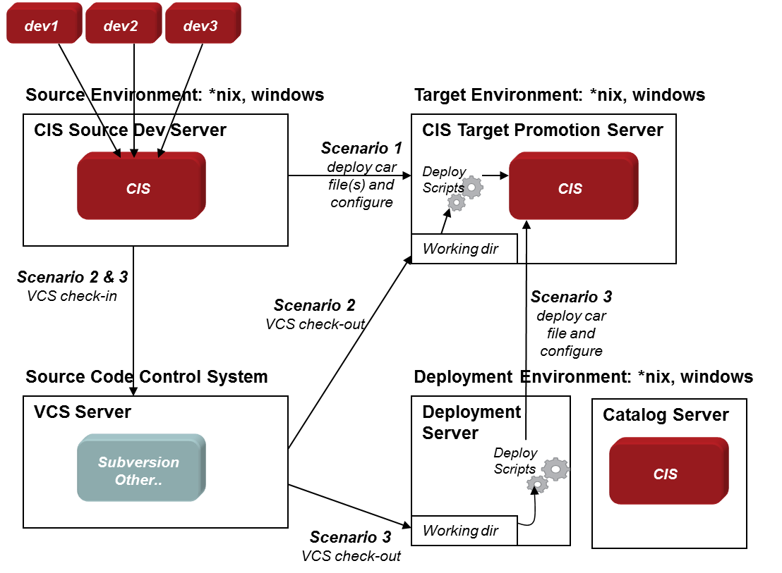

*Figure 1 – Deployment Scenarios*

The diagram depicts the three scenarios and will be described in more detail the ensuing sections. The diagram shows several individual developer workstations feeding changes into a central DV Development Server. The process of getting changes into the Central Development Server is outside the scope of the Promotion and Deployment Tool. The scenarios pick at the point where a deployment is too occur starting with artifacts found in the Central Development Server. The DV Target Promotion Server is where the artifacts will be moved to. A Target server is representative of DV instance such as Test, Integration, UAT, and Production. Customers have different names for these DV instances. The point is with promotion is that there is a source DV instance and a target DV instance. When performing promotion with version control, there will also be a VCS server which is used to check-in and check-out artifacts from DV. Finally, the entire promotion process may need to be executed from a remote server instead of being run on the Target server.

### Scenario 1 – Local CAR file based Deployment

In this scenario the scripts are executed locally on the Target Promotion Server. The PDTool imports a CAR file into the target DV instance and then executes various configuration actions on the target server.

### Scenario 2 – Local VCS based Deployment

In this scenario, the Target Promotion Server is executing the promotion process. Instead of CAR files, the PDTool is interfacing with a VCS server to check-out the specified artifacts, build a car file on the fly and then import into the Target Promotion Server. Additionally, the PDTool will execute various configuration actions on the target DV instance.

### Scenario 3 – Remote VCS or CAR based Deployment

In this scenario, the Target Promotion Server is not involved in executing the PDTool. Instead, there is a dedicated server that will execute the PDTool. The remote promotion server would interface with VCS to check-out the specified DV resources, build a car file on the fly and remotely import into the Target DV Promotion instance. Similarly, if VCS was not involved, it could export specified DV artifacts from the source DV instance and import into the target instance. Finally, the Remote Promotion Server would remotely connect to the target DV instance and execute various configuration actions. A DV instance is not required on the deployment server for the PDTool to function.

1. Promotion and Deployment Matrix

## PDTool Capabilities

The following matrix provides a feature list of Promotion and Deployment Tool:

1. PDTool Feature Matrix

|  |  |
| --- | --- |
| **PDTool Feature** | **Description** |
| Automated Promotion and Deployment | Scripted DV resource promotion using scripts and deployment plans. |
| Command-Line Execution Scripts | Execute a Deployment Plan using Command-line scripts |
| Ant Build Execution Scripts | Execute a Deployment Plan using Ant scripts |
| VCS-based Promotion | Check-out from VCS and import to target DV Server |
| Archive-based Promotion | Use traditional CAR file based deployment |
| Local Promotion | Execute Promotion to Local DV Server |
| Remote Promotion | Execute Promotion to Remote DV Server (DV not required on deployment server) |
| Modular Design | Modular architecture allows for maximum flexibility and the ability to add modules in the future. |
| Archive Module | Performs traditional Import, Export, Backup, Restore |
| Data Source Module | Generate Data Source Module XML file. Update Data Source configurations. Enable and Re-introspect Data Source. |
| Group Module | Generate Group Module XML file. Create or Update Groups. Delete Groups. Add users to groups. Delete users from groups. |
| Privilege Module | Generate Privilege Module XML file. Update Privileges. |
| Rebind Module | Generate Rebind Module XML file. Rebind Resources. Rebind Folders. |
| Regression Module | Perform Regression tests on published JDBC resources using the integrated pubtest capability. Create regression file and execute regression test. |
| Resource Cache Module | Generate Resource Cache Module XML file. Update Resource Cache. Clear and Refresh Resource Cache. |
| Resource Module | Perform various DV Resource related functions such as Execute Procedure, Delete, Rename, Copy, Move, Lock, Unlock and check Resource Exists. |
| Server Attribute Module | Generate Server Attributes Module XML file. Update Server Attributes. Generate Server Attribute Definitions Module XML file. |
| Server Module | Perform Start, Stop and Restart of a DV server. |
| Trigger Module | Generate Trigger Module XML file. Update and Enable Triggers. |
| User Module | Generate User Module XML file. Create or Update Users. Delete Users. |
| Version Control Module | Provides the ability to check-in, check-out, forced check-in and prepare check-in for the following VCS: Subversion, Perforce, CVS and Team Foundation Server (TFS). |

1. Conclusion

## How to get the Promotion and Deployment Tool?

We strongly recommend that a customer receive the Promotion and Deploy Tool (PDTool) via a Professional Services engagement.  PDTool is not a formal product offering from; it is a field-developed utility and is entirely supported from the field.   PDTool comes with pre-built scripts to perform DV resource promotion.   This is a complex area of any enterprise-class platform, and a considerable amount of thought and engineering have gone into the development of the PDTool.  We believe that in order to successfully deploy and support this tool, clients need to engage Professional Services to assist.

A Professional Services engagement can provide the following:

•        Deploy PDTool scripts and binaries (no source code) into the client’s environment.

•        Conduct training on the design and use of the tool.

•        Provide Knowledge Transfer to the customer.

•        Conduct planning sessions with the customer to help architect deployment and promotion plans.

•        Provide a limited amount of email and phone support after the initial, onsite phase of the engagement is completed.

* If necessary and as time allows, enhance or evolve the PDTool to more fully address the client’s unique requirements as outlined by a statement of work.